Super Bowl Brunch Fundraiser
Sunday, February 7, 2021
Boyd Building 303 S. Cherry St., Shell Rock
7:30am-11:30am

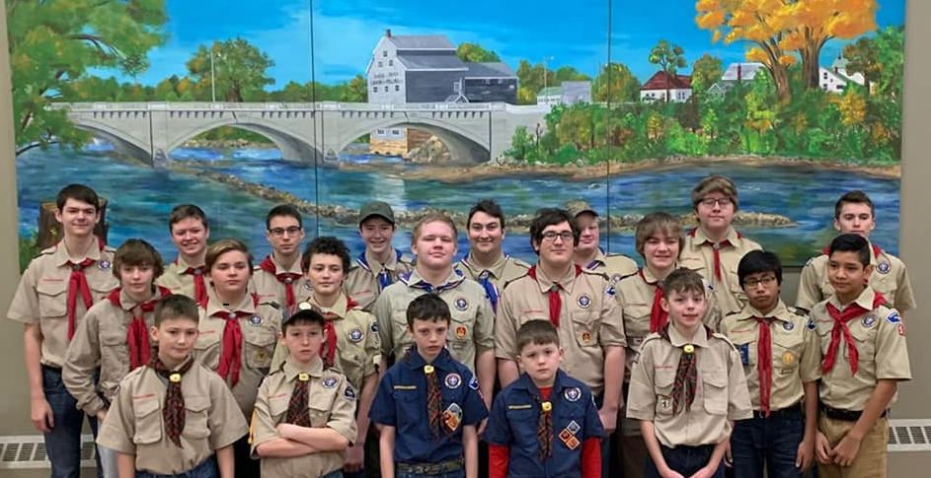

Boy Scout Troop 1051 - Shell Rock IA

Menu
Biscuits and Gravy
Scrambled Eggs
Cheesy Hashbrown Potatoes
Sausage Links
Pancakes
Coffee, Milk, Juice, Hot Chocolate
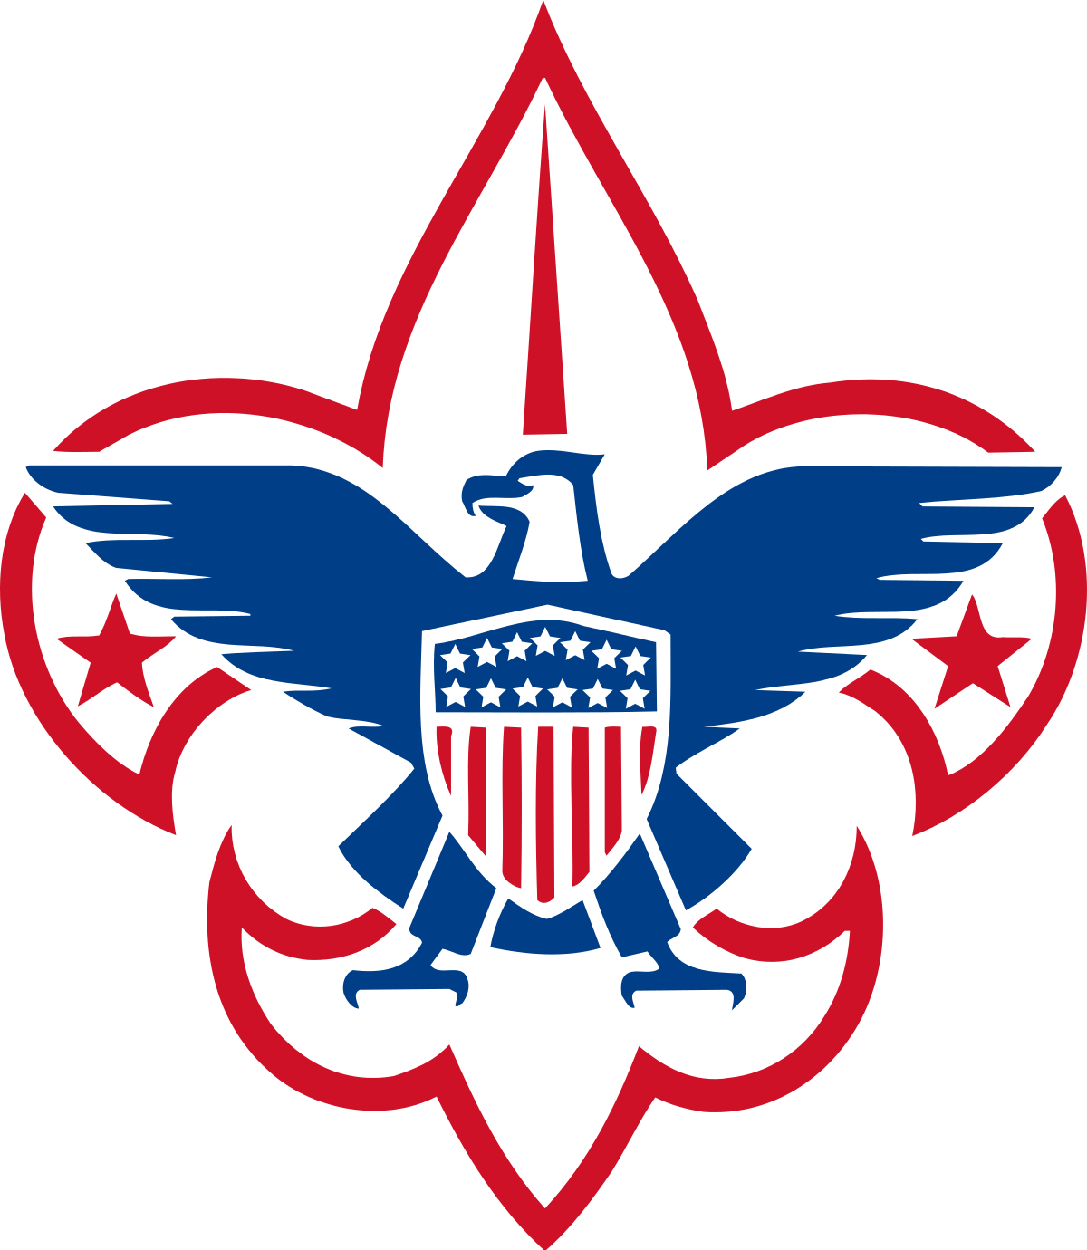
Cost: Free will offering
Carry outs Available

